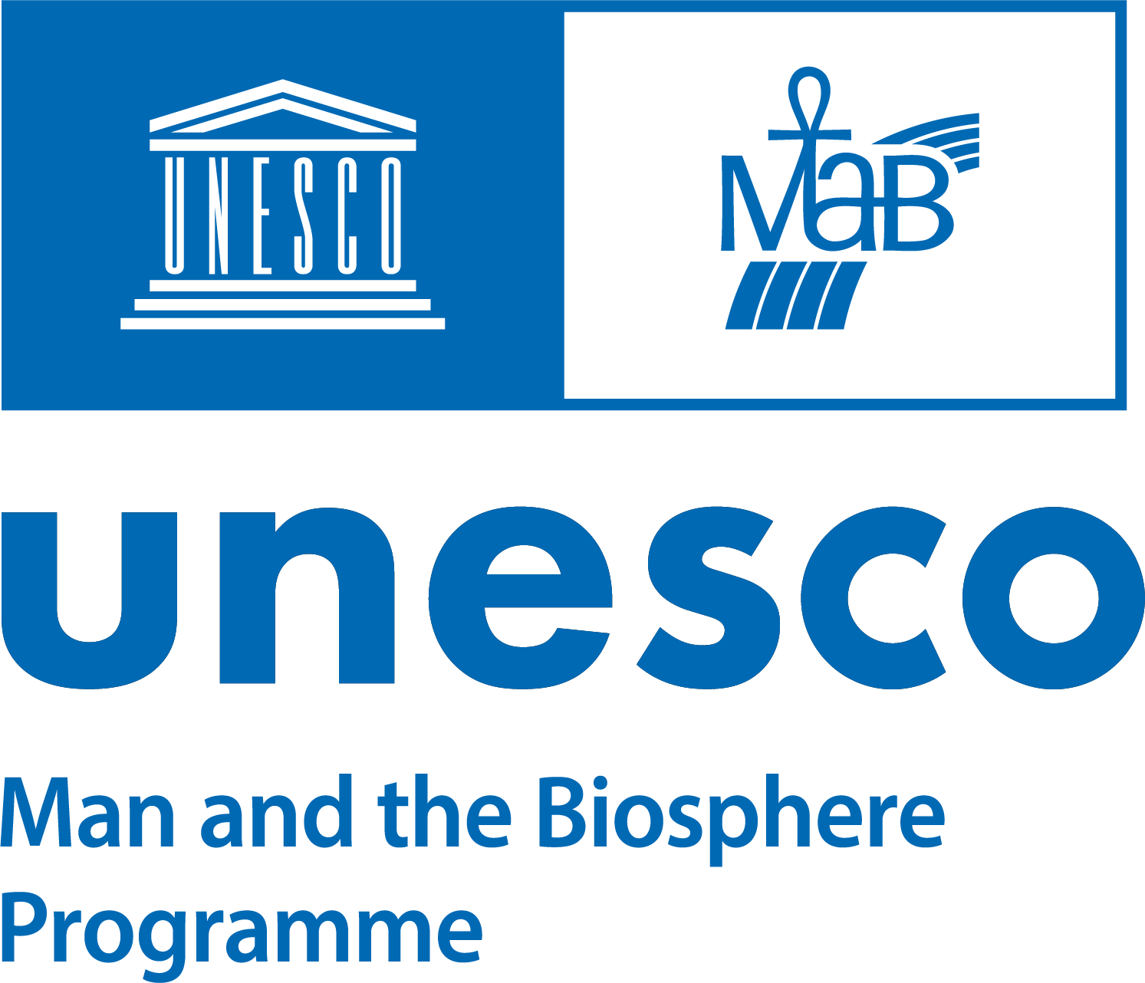

APPLICATION FOR THE YEAR 2025

MAB YOUNG SCIENTISTS AWARDS

“人与生物圈计划”青年科学家奖2025年度申报表

Please fill in and sign your application and mail it to your MAB National Committee in your home country for endorsement before it is sent to: MAB Secretariat, Division of Ecological and Earth Sciences, UNESCO, 7, place de Fontenoy, 75352 Paris 07 SP, France. Applications must be received by UNESCO no later than 15 May 2025 to be eligible. ONLY APPLICATIONS IN ENGLISH AND FRENCH ARE ACCEPTED.
请填写并签署申报表，邮寄至您所在国家的“人与生物圈计划”国家委员会进行审核，审核通过后寄送至：联合国教科文组织生态与地球科学部人与生物圈计划秘书处，法国巴黎丰特努瓦广场7号，75352巴黎07区。
申报表须在2025年5月15日前送达联合国教科文组织方为有效。（仅接受英文或法文申报）

1. LAST NAME: _____________________________ | 2. First name: _____________________________
姓  3. Date of birth: _ | 名  4. Sex: Male / Female
出生日期  5. Nationality: _____________________________  国籍 | 性别：男/女  6. Profession: ______________________________  职业
7. Complete address:
完整地址
_______________________________________________________________________________________

_______________________________________________________________________________________

________________________________________________________________________________________

Tel: ________________________________
电话
E-mail: __________________________________________________________________________________
电子邮箱
8. Educational qualifications:
教育背景
Institution | Date | Degree/Diploma
受教育机构  ________________________________  ________________________________  ________________________________ | 日期  _____________  _____________  _____________ | 学位/文凭  _______________________________  _______________________________  _______________________________

9. Previous research experience: ________________________________________________________________
既往研究经历
________________________________________________________________________________________

________________________________________________________________________________________

10. Country where research is to be undertaken (in case the study is planned in countries other than the applicants’ home country, please attach written evidence to indicate the support of the MAB National Committee concerned):
研究开展国家（若研究计划在申报人在籍国以外的国家进行，请附相关国家“人与生物圈计划”国家委员会的支持证明）
________________________________________________________________________________________

11. Title of study: ___________________________________________________________________________
研究题目
________________________________________________________________________________________
12. Summary description of the proposed research study. Highlight main purposes, methods and expected results of the research to be undertaken. If necessary, you may add up to two more pages (no additional material, e.g. certificates, articles, CV, etc. should be annexed to the application):
研究计划摘要。请概述研究的主要目的、方法及预期成果。如有必要，可额外添加两页内容（请勿附加证书、文章、简历等其他材料）

13. a) Indicate if and how the proposed study will relate/contribute to your country’s MAB Programme and the UNESCO MAB Youth Network.
a) 说明拟开展的研究如何关联或贡献于贵国的“人与生物圈计划”及联合国教科文组织人与生物圈青年网络。
___________________________________________________________________________

_________________________________________________________________________________________

_________________________________________________________________________________________

___________________________________________________________________________

b) Is the research site in a UNESCO designated biosphere reserve? Yes / No
研究地点是否位于联合国教科文组织指定的生物圈保护区？是 / 否
If so, in which biosphere reserve? ________________________________________________________________
若是，请注明保护区名称：

14. Indicate if and how the proposed study will relate or contribute to the implementation of the Lima Action Plan (LAP) and the Sustainable Development Goals (SDGs).
a) Identify action(s) of the LAP addressed specifically by the research.
b) List SDGs and target(s) towards which the research makes a direct contribution.
说明拟开展的研究如何关联或贡献于《利马行动计划》（LAP）及《联合国2030年可持续发展目标》（SDGs）的实施。
a) 指出研究涉及的具体LAP行动。
b) 列出研究直接贡献的SDGs及具体目标。

15. Provide concise information on past and existing research in areas concerned to present linkages and avoid duplications and financing of projects already carried-out
提供与本研究相关领域既往及现有研究的简要信息，以展示关联性并避免重复资助已完成的课题。

16. Expected starting date and duration of the study____________________________________________________
研究预计开始日期及持续时间：

17. Expected date for submission of final report to MAB National Committee, or UNESCO National Commission
向“人与生物圈计划”国家委员会或联合国教科文组织国家委员会提交最终报告的预计日期：
___________________________________________________________________________

18. Name(s) of institution(s) associated with the study and support provided by the institution(s)
参与研究的机构名称及其提供的支持：
_________________________________________________________________________________________

_________________________________________________________________________________________

19. Estimated cost of the proposed study and amount requested from UNESCO-MAB. (Individual research grants will be made available up to an amount of US $5,000. Smaller requests have greater chances of approval. Please clearly indicate the total amount requested, and a breakdown of expenditures, in US $.)
研究预计费用及向联合国教科文组织人与生物圈计划申报的资金金额（单项研究资助上限为5,000美元，金额较小的申报更易获批。请以美元为单位注明申报总额及支出明细）：
________________________________________________________________________________________

________________________________________________________________________________________

________________________________________________________________________________________

________________________________________________________________________________________

________________________________________________________________________________________

_______________________________________________________________________________________

(Date) (Signature of Applicant)
（日期） （申报人签名）

NB: Your application must be signed on page 4 by your MAB National Committee*
注意：您的申报表第4页必须由“人与生物圈计划”国家委员会签署*

APPLICATION ENDORSED BY PRESIDENT / SECRETARY OF MAB NATIONAL COMMITTEE*
FOR SUBMISSION TO UNESCO
“人与生物圈计划”国家委员会主席/秘书长审核意见*
同意提交联合国教科文组织

(DATE) (SIGNATURE of President / Secretary of the MAB National Committee)
（日期） （“人与生物圈计划”国家委员会主席/秘书长签名）

(NAME of President / Secretary of the MAB National Committee)
（“人与生物圈计划”国家委员会主席/秘书长姓名）

MAB National Committee address:
“人与生物圈计划”国家委员会地址：

Tel.:
电话：
E-mail:
电子邮箱：

NOTE TO MAB NATIONAL COMMITTEES* AND APPLICANTS
致“人与生物圈计划”国家委员会及申报人的说明

Criteria for endorsement and selection of MAB Young Scientists Awards

- To be eligible, award applications must be made on the MAB Young Scientists Award application form (in English or French) and follow-up technical requirements stated there. The application must be endorsed by the applicant's MAB National Committee*, which may endorse only two applications per year from applicants who are not older than 35 years of age (at the closing date of the application).

- Applications must contain concise information of past and existing research in areas concerned in order to present linkages and avoid duplications and financing of projects already carried-out.

- Priority is given to interdisciplinary projects carried out in biosphere reserves designated under the Man and the Biosphere Programme or potential biosphere reserves, and which contribute to the implementation of the Lima Action Plan (LAP) for Biosphere Reserves and the Sustainable Development Goals (SDGs). In this regard, applicants shall identify in their applications if and how their research contributes to the research-related actions of the LAP and to the SDGs.

- Applicants from developed countries are eligible for Awards only in exceptional cases or if working in joint partnership with developing countries.

- Awards are set at a maximum of US $5,000 each.

- Research supported by an Award should be completed within 2 years.

- Candidates must accept to submit reports of Award funded research to the MAB Secretariat in Paris and to their MAB National Committees*, and agree to the possibility of UNESCO publishing the results of their research.

- International travel expenditures are usually not covered under these Awards.

人与生物圈青年科学家奖审核及评选标准
- 须使用本申报表申报（英文或法文），并符合相关技术要求，经申报人所在国“人与生物圈计划”国家委员会审核通过后方为有效。各国委员会每年最多可推荐两名年龄不超过35周岁（以申报截止日期为准）的申报人。
- 申报材料需包含与本研究相关领域的既往及现有研究简要信息，以展示关联性并避免重复资助已完成的课题。
- 优先支持在世界生物圈保护区或潜在类似保护区开展的跨学科研究项目，且研究需有助于《利马行动计划》（LAP）及《联合国2030年可持续发展目标》（SDGs）的实施。申报人需在申报中明确说明研究如何关联LAP中的科研行动及SDGs。
- 发达国家申报人仅在特殊情况下（如与发展中国家合作）方可获资助。
- 单项资助上限为5000美元。
- 获资助研究须在2年内完成。
- 获资助者需同意向“人与生物圈计划”秘书处及本国国家委员会提交研究报告，并允许联合国教科文组织公开研究成果。
- 国际旅费通常不纳入资助范围。

*For the countries in which a MAB National Committee does not exist or is not fully operational, the National Commission for UNESCO will ensure the selection of candidates according to the above criteria.
若某国未设立“人与生物圈计划”国家委员会或委员会未正常运作，由该国联合国教科文组织国家委员会根据上述标准进行候选人选拔。

Payment Procedure for MAB Awards
Award payments are split into two instalments:
1st payment: Upon receipt and approval by UNESCO of two signed copies of the Letter of Agreement accompanied by a calendar of activities for the research study.
2nd payment: Upon receipt and approval by UNESCO of a final report (duly signed by the MAB National Committee) as well as a letter authorizing UNESCO to use the information from the report in UNESCO publications and on the UNESCO-MABnet.
资助款项分两次发放：
第一次：收到经联合国教科文组织批准的两份《研究协议》签署件及研究活动时间表后支付。
第二次：收到经“人与生物圈计划”国家委员会签署的最终报告，并授权联合国教科文组织在出版物及MABnet平台使用报告信息后支付。

Application forms for MAB Young Scientists Awards are available from:
MAB Secretariat, Division of Ecological and Earth Sciences,
UNESCO
7, place de Fontenoy, 75352 Paris 07 SP, France.
E-mail: m.prchalova@unesco.org; mab.awards@unesco.org; mab@unesco.org
MAB Young Scientists Awards on the Web: https://www.unesco.org/en/man-and-biosphere/young-scientists
“人与生物圈计划”青年科学家奖申报表可从以下地址获取：
联合国教科文组织生态与地球科学部人与生物圈计划秘书处，
法国巴黎丰特努瓦广场7号，75352巴黎07区。
电子邮箱：m.prchalova@unesco.org; mab.awards@unesco.org; mab@unesco.org
“人与生物圈计划”青年科学家奖官网：
https://www.unesco.org/en/man-and-biosphere/young-scientists

